**Exp3_Aim: To explore files and directories in python**

### THEORY:

1. List the importance of files and various modes in python

Ans:

Importance of files in python-

Python provides us with an important feature for reading data from the file and writing data into a file. If we want to read the data from a file or write a data into the file, we will first open a file or create a new one if the file doesn’t exist and then perform the normal read and write operations, save the file and close it. This all functions can be done using built in methods/ functions in python.

Modes-

There are different modes of file in which it can be opened.

They are mentioned in the following table.

A File can be opened in two modes:

1) Text Mode.

2) Binary Mode.

1. r for reading – The file pointer is placed at the beginning of the file. This is the default mode.
2. r+ -Opens a file for both reading and writing. The file pointer will be at the beginning of the file.
3. w -Opens a file for writing only. Overwrites the file if the file exists. If the file does not exist, create a new file for writing.
4. w+ -Opens a file for both writing and reading. Overwrites the existing file if the file exists. If the file does not exist, it creates a new file for reading and writing.
5. rb Opens a file for reading only in binary format. The file pointer is placed at the beginning of the file.
6. rb+ -Opens a file for both reading and writing in binary format.
7. wb+ -Opens a file for both writing and reading in binary format. Overwrites the existing file if the file exists. If the file does not exist, it creates a new file for reading and writing.
8. a -Opens a file for appending. The file pointer is at the end of the file if the file exists. That is, the file is in the append mode. If the file does not exist, it creates a new file for writing.
9. ab - Opens a file for appending in binary format. The file pointer is at the end of the file if the file exists. That is, the file is in the append mode. If the file does not exist, it creates a new file for writing.
10. a+ - Opens a file for both appending and reading. The file pointer is at the end of the file if the file exists. The file opens in the append mode. If the file does not exist, it creates a new file for reading and writing.
11. ab+ -Opens a file for both appending and reading in binary format. The file pointer is at the end of the file if the file exists. The file opens in the append mode. If the file does not exist, it creates a new file for reading and writing.
12. x - open for exclusive creation, failing if the file already exists (Python 3)
13. Write all directory commands

Ans:

Get current Directory getcwdb()-

This method returns the current working directory in the form of a string.

Change Directory chdir()-

We can change the current working directory by using chdir() method.

List Directories and Files-

All files and sub-directories inside a directory can be retrieved using the listdir() method.

Making a new Directory-

We can make a new directory using the mkdir() method. This method takes in the path of the new directory.

Renaming a directory or a file-

The rename() method can rename a directory or a file. For renaming it takes two arguments, the old as first and new as a second argument.

Removing Directory or File-

The file gets deleted after using the remove() method. Similarly the rmdir() method removes an empty directory.

### IMPLEMENTATION:

### Python program to append data to existing file and then display the entire file

**CODE:**

n_file = open("new.txt", "a")

n_file.write("This is the new line")

**Output:**

Before Output:



After Output:

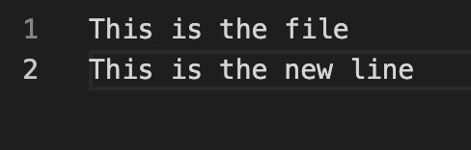

### Python program to count the number of lines, words and characters in a file.

**CODE:**

def counter(fname):

num_words = 0

num_lines = 0

num_charc = 0

num_spaces = 0

with open(fname, 'r') as f:

for line in f:

num_lines += 1

word = 'Y'

for letter in line:

if (letter != ' ' and word == 'Y'):

num_words += 1

word = 'N'

elif (letter == ' '):

num_spaces += 1

word = 'Y'

for i in letter:

if (i != " " and i != "\n"):

num_charc += 1

print("Number of words in text file: ", num_words)

print("Number of lines in text file: ", num_lines)

print('Number of characters in text file: ', num_charc)

print('Number of spaces in text file: ', num_spaces)

if _name_ == '_main_':

fname = 'trial.txt'

try:

counter(fname)

except:

print('File not found')

**OUTPUT:**

trial.txt

Lorem ipsum dolor sit amet, consectetur adipisicing elit, sed do eiusmod

tempor incididunt ut labore et dolore magna aliqua. Ut enim ad minim veniam,

quis nostrud exercitation ullamco laboris nisi ut aliquip ex ea commodo

consequat. Duis aute irure dolor in reprehenderit in voluptate velit esse

cillum dolore eu fugiat nulla pariatur. Excepteur sint occaecat cupidatat non

proident, sunt in culpa qui officia deserunt mollit anim id est laborum.

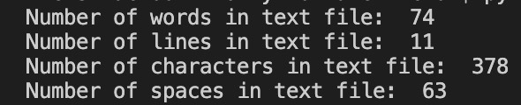

### Python program to display file available in current directory

**CODE:**

import glob, os

print("Enter Full Path of a Folder: ", end="")

path = input()

os.chdir(path)

print("\n1. List all Files ?")

print("2. List all Files with Particular Extension ?")

print("Enter Your Choice (1 or 2): ", end="")

try:

ch = int(input())

if ch==1:

print("\nList of All Files:")

for file in glob.glob("*.*"):

print(file)

elif ch==2:

print("\nEnter the Extension (eg, .txt, .html, .css etc): ", end="")

e = input()

fileslist = []

for file in glob.glob("*" + e):

fileslist.append(file)

if len(fileslist) > 0:

print("\nList of All Files with \"" + e + "\" Extension:")

for f in fileslist:

print(f)

else:

print("\nNot found with \"" + e + "\" extension!")

else:

print("\nInvalid Choice!")

except ValueError:

print("\nInvalid Input!")

**OUTPUT:**

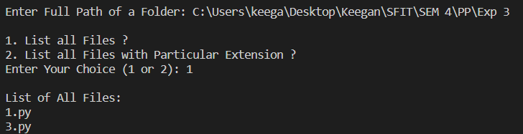

### Conclusion:

Successfully learnt to read and write in files using Python features.